**Screenshots of the table with only data type of the attributes**

**Admin:**

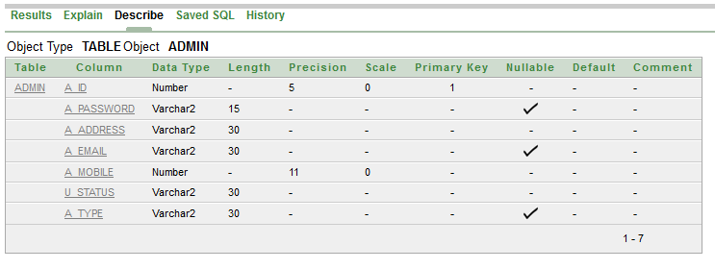

**Seller:**

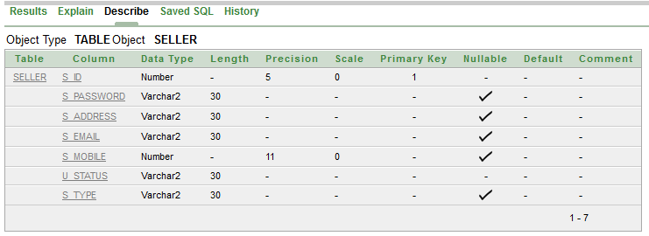

**G_user:**

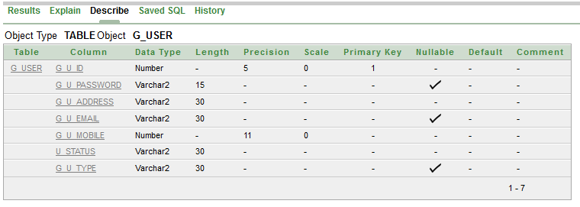

**Seller_name:**

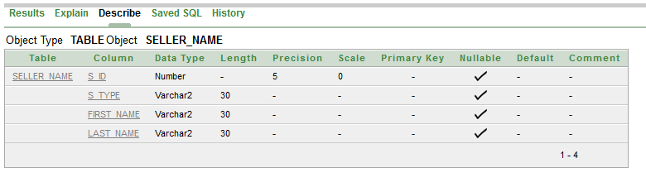

**Admin_name:**

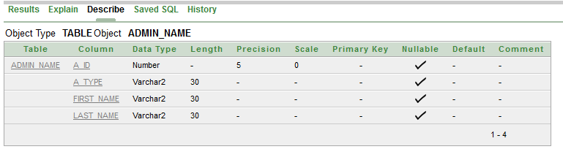

**G_user_name:**

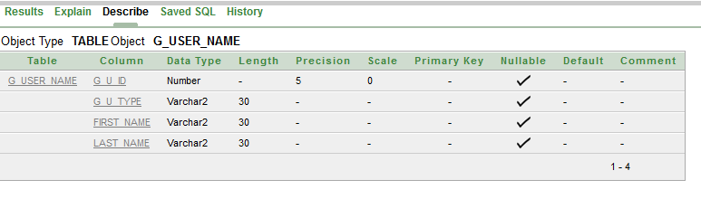

**Msg:**

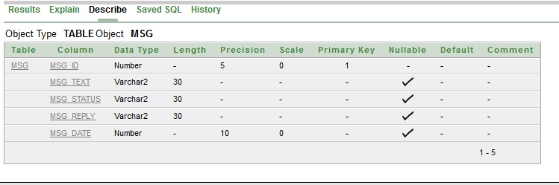

**Msg_seller_admin:**

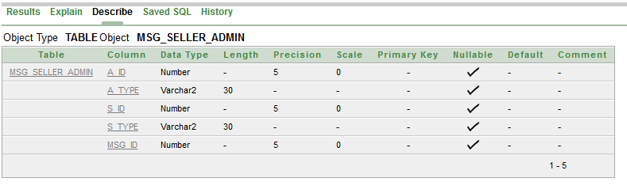

**Msg_g_user_admin:**

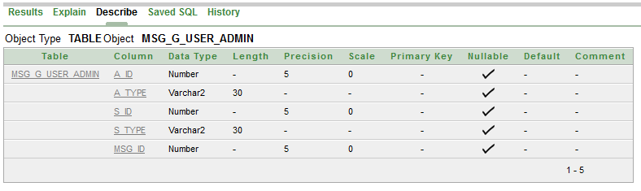

**Promo:**

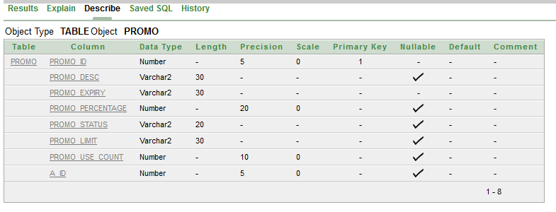

**Promo_use:**

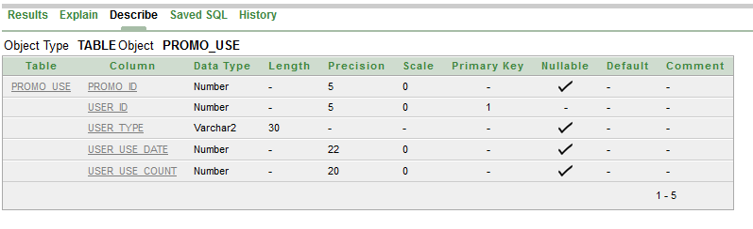

**Wishlist:**

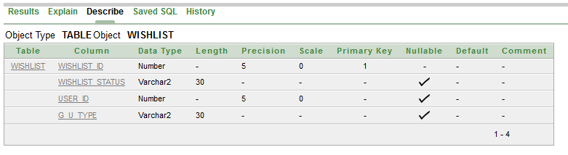

**P_include_wishlist:**

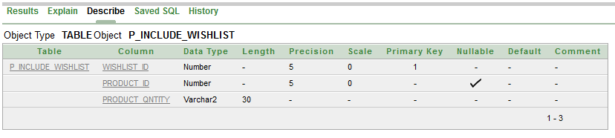

**P_include_cart:**

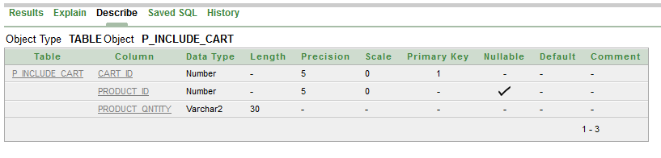

**Cart:**

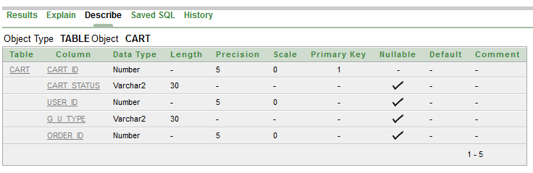

**Order_t:**

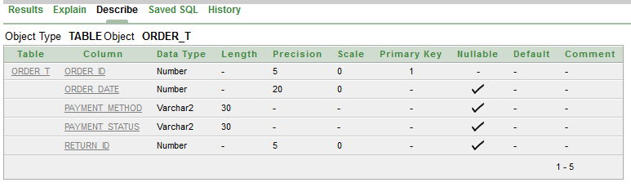

**Return_t:**

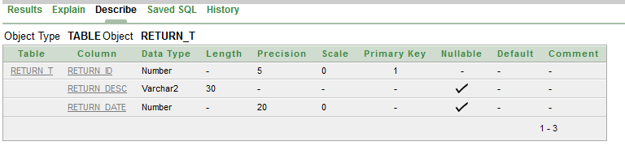

**Products:**

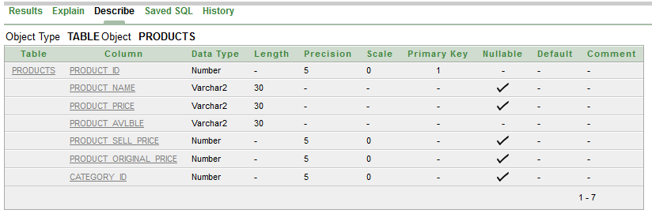

**Catagories:**

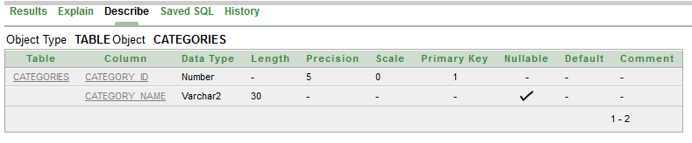

**Supply_order:**

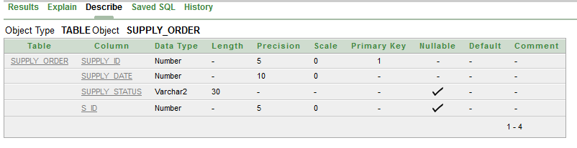

**Supply_contains:**

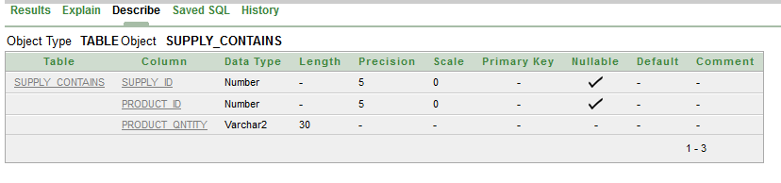

**Give_review:**

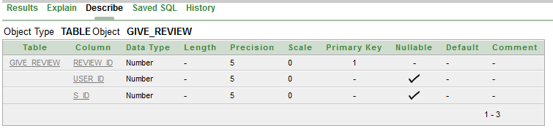

**Review:**

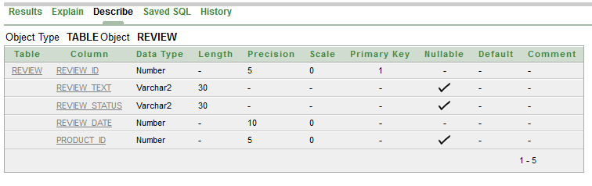

**Visit:**

